|  |  |
| --- | --- |
| **BMRPOA, Inc.**  **PO Box 797**  **Stanhope, NJ 07874** | **Office:** 973-347-1040 | **Fax:** 973-347-1767  **Email:** bmrpoa@gmail.com  **Website:** www.bmrpoa.homestead.com  **Facebook:** [**www.facebook.com/WestBrookwoodBmrpoa**](http://www.facebook.com/WestBrookwoodBmrpoa) |

#### COMMUNITY NEWS

 Congratulations to the two 2019 scholarship winners,

**Nicolle Fekete** of Sussex County Technical H.S. and **Dylan Kuncken** of Lenape Valley Regional H.S.

We wish them much success.

**BOARD NEWS**

Thank you for sending in your ballots with your Dues payment in May. As a result, we gave a warm welcome to the write-in candidate, **Barbara Kostiuk**. She has served as a governor in the past. She was re-elected as governor (a 2-year term) and re-elected as officer (a 1-year term).Barbara will be a grand addition to the board.

By the way, if you or someone you know are still interested in joining the board but did not have a chance to complete the ballot then, please do. You may email your decision to bmrpoa@gmail.com.

West Brookwood’s Association meetings are open to the public and mostly held on the fourth Wednesday of the month at Byram Township, Town Hall at 7:30 PM.

Meetings are scheduled for the year and can be viewed on our website: [www.bmrpoa.homestead.com](http://www.bmrpoa.homestead.com). Please come out to a meeting or two and hear what is happening in your community.

**PET OWNERS**

Specifically, dog owners, of Byram Township, please be reminded:

* License your dog with the township
* update their rabies shots
* walk with a leash
* securely fence in if not on a leash

* pick up after your pet to save our environment, (rivers, streams, etc.)
* carry necessary items for easy clean
* Please keep off property or property lines of others

Kindly adhere to these rules and ordinances. Avoid any nuisance to others from excrement left uncleaned and please refrain from walking near the Well at Chestnut and the River. Thank you for your cooperation.

### ANNOUNCEMENTS

Congratulations to the Haak Family of 34 Broad Avenue on their new baby boy!

Carson Anthony Haak was born 6/6/19 at 7:07 pm and weighs 6 pounds 12 ounces.

Do you wish to share or hear of good news? If you have a birth, graduation, someone going into or coming home from the military, etc., please email your Facebook Administrator, Jacie Woznicki at jacie.woz@gmail.com and share your news as your neighbors would like to congratulate you.

**FUN & GAMES**

**West Brookwood Word Search**

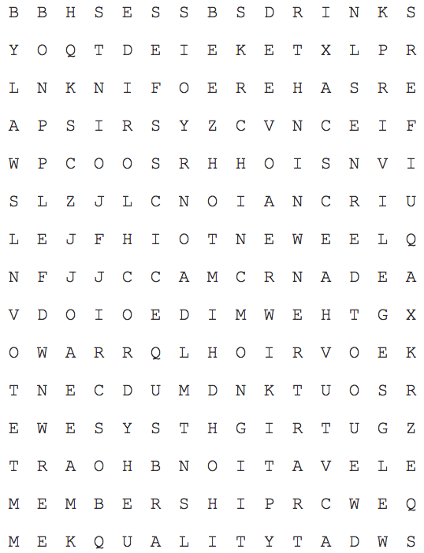AQUIFERS LICENSE

BYLAWS MEMBERSHIP

COMMITTEES OWNER

DRINK PRIVILEGES

ELEVATION QUALITY

FROZEN RIGHTS

GOVERNORS RECREATIONAL

HYDROCHLORIDE SERVICE

INCHES TECHNICIAN

JOINTS VOTE

KEYS WATER

**IN THE KNOW…**

**Board of Governors 2019-2020**

Masoud Joudi, *President*  
Janice Drace, *Vice President*

Keri Weber, *Treasurer*  
David Pinkham, Jr, *Secretary*  
George Ondish, *Governor*  
Barbara Kostiuk, *Governor*  
Open, *Governor*   
Open, *Governor*   
Open, *Governor*

**Know Your Street Representative**

**Acorn:** Lissette Hernandez 973-219-7329

**Adair:** *OPEN*

**Ash/Union:** *OPEN*

**Avon:** *OPEN*

**Banker:** Helen Perri 201-919-8028

**Beech:** *OPEN*

**Belton:** Laura McVicar 973-448-8680

**Broad:** Elaine Carr 973-347-4461

**Chestnut/Waterloo:** Kathy Stevenson 973-448-8869

# Glen Brook/Lower River: Dee Garrison 973-229-5784 Lauren: *OPEN*

**Lockwood:** Kristi Bristol 732-735-5931

**Mayne:** Joe Tedeschi 862-221-1146

**Robert:** Dolores Bollinger 973-769-7345

# Springbrook/Upper River: Yvonne Reeves 973-347-8807

#### We are looking for volunteers for street reps!

**Call or email the office today if you are interested.**