Know Your Street Representative

Acorn………….......Lissette Hernandez….....….219-7329
Adair…................Janet Durica.......................219-2056
Ash/Union….......Dolores Bollinger….............769-7345
Avon..................Wallace Krake………...……....691-9489
Banker................Helen Perri..…...……..(201) 919-8028
Beech.................Kevin Tevis……………………...879-4528
Belton…………......Laura McVicar....................448-8680
Broad………….......Elaine Carr.........................347-4461
Chestnut/Waterloo…...Kathy Stevenson......448-8869
Glen Brook/Lower River…..Dee Garrison......229-5784
Lauren…………………………………………………….……...OPEN
Lockwood…........Kristi Bristol…….…….….732-735-5931
Mayne………….....Joe Tedeschi….………...862-221-1146
Robert……….…....Carol Tarnowski….……….....670-3701
Springbrook/Upper River...Yvonne Reeves.347-8807

West Brookwood
Board of Governors 2017-2018
Masoud Joudi..........................President
Janice Drace.....................Vice President
Keri Weber..............................Treasurer
David Pinkham, Jr.....................Secretary
George Ondish.........................Governor
Open.......................................Governor
Open.......................................Governor
Open.......................................Governor
Open.......................................Governor
Members:
Meetings are scheduled the 4th Wednesday
of the month at the
Byram Municipal Building at 7:30 pm.
Please check your e-mail for the meeting agenda.

Congratulations to our local student performers!

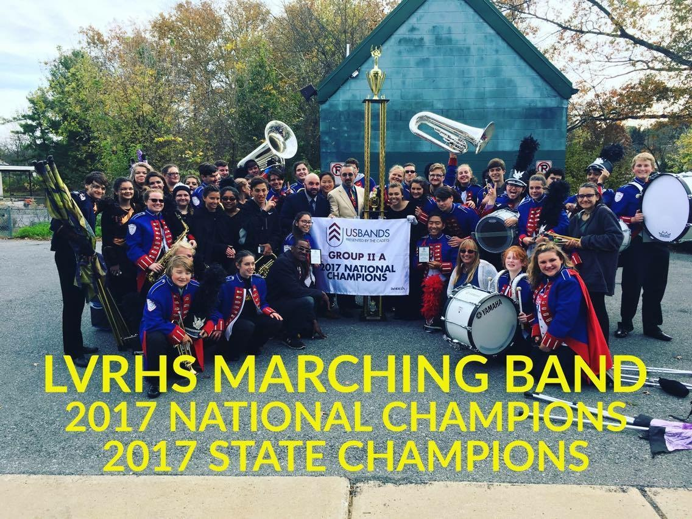

Lenape Valley Regional High School Marching Band, directed by Mr. David DiGrazia, took 1st Place at both US Bands 2A State and National Competitions on Saturday, November 4. The 2017 Color Guard Section was given the honor of 1st Place the entire 2017 marching band season. The band was given a wonderful parade entrance back to the school from Route 80 by the local emergency responders after their big wins.

2017 US Bands National Champions Group IIA
93.313
Best Overall Effect, Best Color Guard

2017 US Bands NJ State Champions Group IIA
96.438
Best Overall Effect, Best Music, Best Visual Effect, Best Color Guard
2017 Undefeated Color Guard

West Brookwood
Newsletter

Winter 2018

BMRPOA, Inc.
PO Box 797
Stanhope, NJ 07874

Office: 973-347-1040
Fax: 973-347-1767

E-mail:
bmrpoa@gmail.com
Website:
www.bmrpoa.homestead.com
Facebook: www.facebook.com/WestBrookwoodBmrpoa

WINTER WEATHER REMINDER

Please be aware when snow is predicted there is NO parking on the street. Further information regarding this can be found on the town’s website: www.byramtwp.org

WINTER DECORATING CONTEST
WINNERS

Best Use of Lights
1ST: 22 Mayne Avenue
2ND: 57 Belton Street
3RD: 30 River Road

Honorable Mentions for Lights
20 Lauren Court, 1 River Road,
9 Broad Avenue, 67 Ash Street,
28 Mayne Avenue, 9A Chestnut street

Best Use of Decorations
1ST: 14 Chestnut Street
2ND: 33 Lockwood Avenue
3RD: 80 River Road

Honorable Mentions for Décor
31 Broad Avenue, 51 River Road,
1 Springbrook Street, 49 Mayne Avenue,
10 Broad Avenue, 29 Waterloo Road

FROM YOUR WATER DEPARTMENT
To enhance communication during an emergency, we will be using an Automation-Text messaging system. One member of each household will be notified of an emergency via a text message. This will be provided at no cost to membership.

If you would like to be informed of emergencies through an automated text message, then please provide the following information to the office via email to bmrpoa@gmail.com:
Name, Address and Cell Phone Number

NOTE: Customers who have not yet responded and have more than one cell phone number listed with the Water Department need to choose which one to use as an emergency text message.
Also, customers without a cell phone will continue to receive a phone call for emergencies.
Thank you for your cooperation.

HIGH SCHOOL SENIORS

A $500 Scholarship will be awarded to a senior high school student of West Brookwood. The applications will be available in your school Guidance Office by the 2nd week of January. Follow the instructions and return the application by April 1, 2017. If you have any questions, call the office.

Also, any student looking for community service hours can call the office for more details at 973-347-1040.

NEW TO BYRAM RESIDENTS
"No Solicitation List"
On February 2, 2016 Byram Township amended Chapter 164 entitled "Licensing" to establish a NO solicitation list and to modify the hours of operation and fees. Byram Township will be maintaining a list in the Municipal Clerk's office of residents who request that solicitors do not solicit on their property. This list will be updated annually.
Should you wish to be put on this list, please email Cindy Church at cchurch@byramtwp.org or submit your request in writing to: Cindy Church, Deputy Clerk, Byram Township, 10 Mansfield Drive, Stanhope, NJ 07874

NEXT EVENT COMING SOON…
Cinépolis Succasunna
Sunday, March 4, 2018 from 11:00am to 2pm
Meet & Greet for Pizza in the theatre then off to a matinee movie of your choice.

Limited FREE tickets for the first 50 members. The ticket will include: admission to a matinee movie and pizza. Please email your request to bmrpoa@gmail.com. If you do not have a computer, call the office:
973 347-1040 during business hours.
*If your plans change after requesting
tickets, please call the office so that the
next person on the waiting list can be
accommodated.
Thank you.

